



Registration Request (Parent Organization)

Before you start you will need your facility name and address. To register your Organization, select “Register” and on the next screen enter the required information.

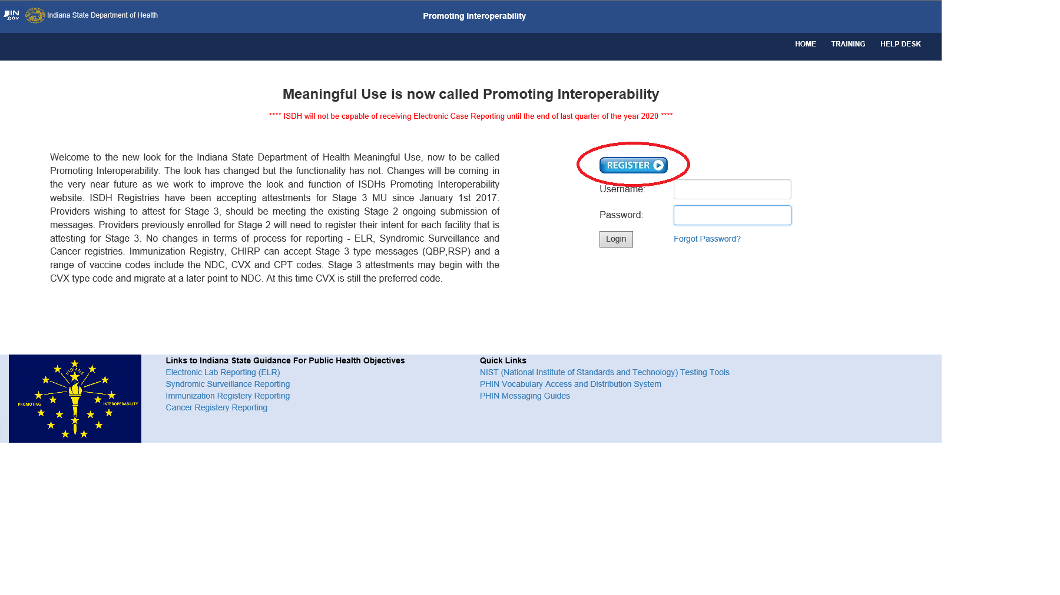

Once Register is selected

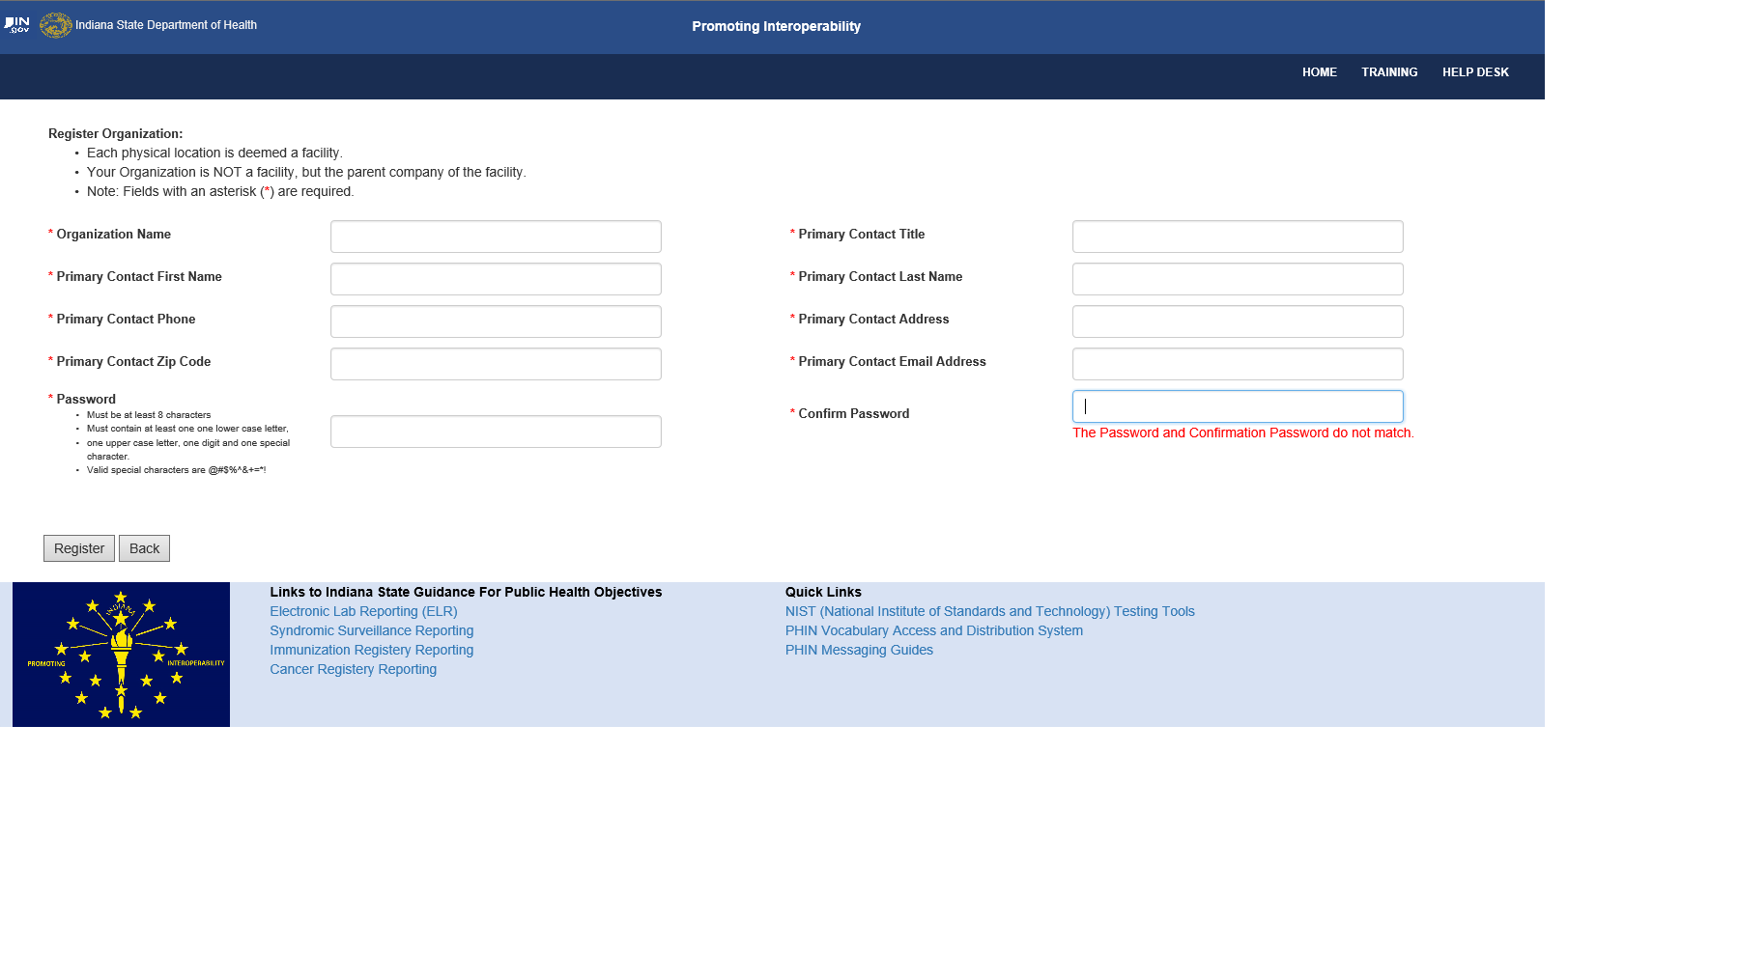

Please note that if any required information is missing or invalid a note will display to the right of the text box and the Register button will not create a pop-up message when clicked. Remember the password must be at least 8 characters and contain:

• One lower case letter,

• One upper case letter,

• One number, and

• One special character @#$%^&+=*!

If your Organization has already registered, you will receive a pop-up stating the name is already in use like below:



You will receive a pop-up stating that your registration request has been received. This does not mean your registration is complete;

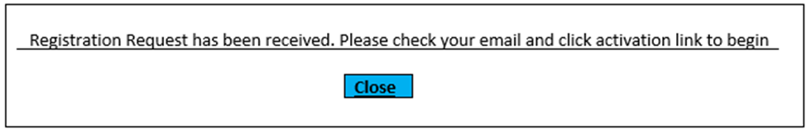

Check your email and follow the instructions included in that email.

Forgot Password

If you forget your password, click the “Forgot Password” link and you see the following screen with instructions;

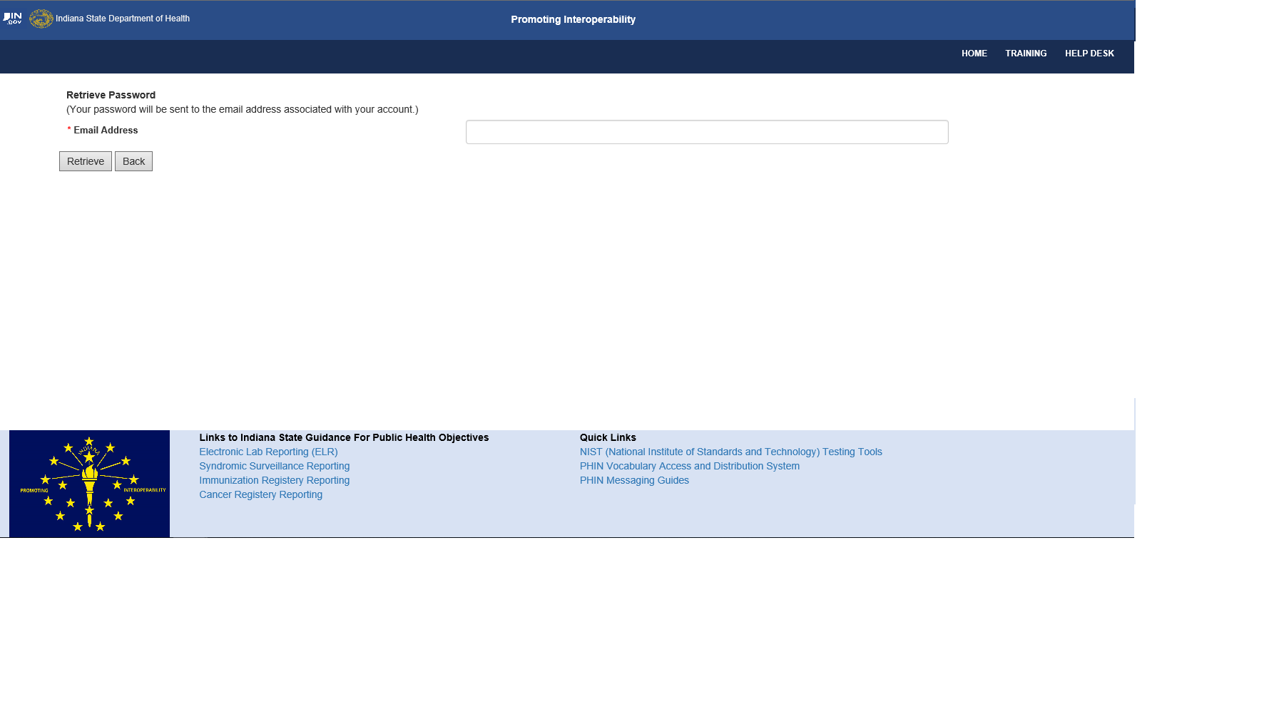

Insert email address your registered with, select retrieve. A pop-up will display with a message that the password was sent to your email;



An email from isdhelrss@isdh.in.gov with the same password that you registered will be sent to the associated email.

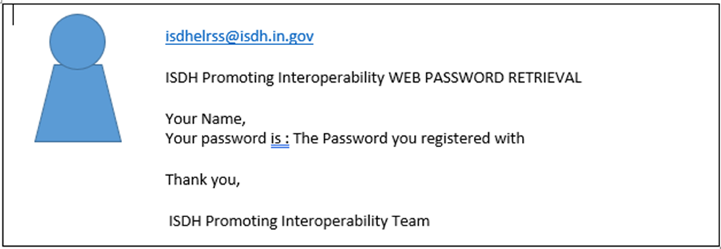

Request Direct Connection (SFTP) for ELR and Syndromic Surveillance

After successfully logging into the Promoting Interoperability website the parent organization will be listed under “Organization Name” header. ISDH maintains an internet accessible Secure File Transfer Protocol (SFTP) server for secure transfer of data files. If you choose to Request Direct Connection (SFTP) you will need to choose a registry (Syndromic Surveillance or ELR) as seen below:

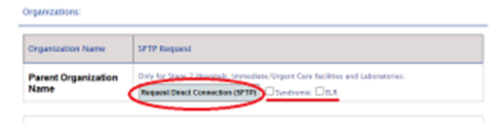

This Direct Connection request will create only test and production folders for Syndromic Surveillance and ELR based on what your facilities have chosen. Please contact the Immunization or Cancer Registry contacts directly if a direct connection is needed. Contact phone numbers and emails can be found by clicking on the Contact Us section of the Promoting Interoperability Home page.

A pop-up that the SFTP request has been sent;

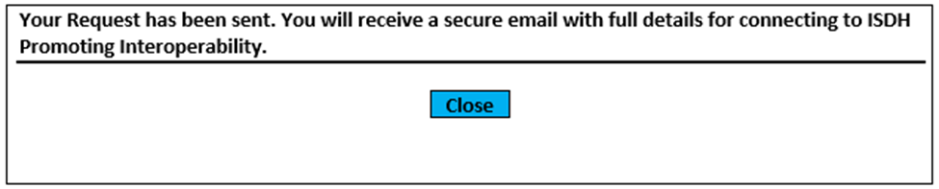

An email will be sent within 5 to 7 business days when the user is approved. The “Request Direct Connection (SFTP)” button will be replaced with the date and time when the request for SFTP was requested. It will appear as below;

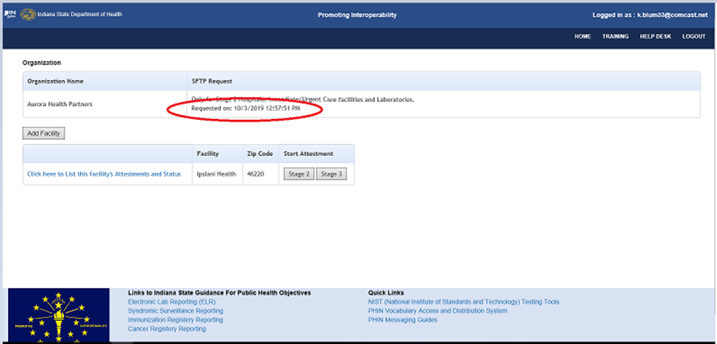

Add a New Facility

Once registered, the parent organization can “ADD” additional facilities; Before you start you will need your NPI and your facility Medicare Certification number.

Step 1- to add a new facility (each distinct physical location is considered a facility) select the add facility button as shown below:



Step 2- enter all the required information for the facility being added. The “Continue” button will not send the information if all the required information is not completed.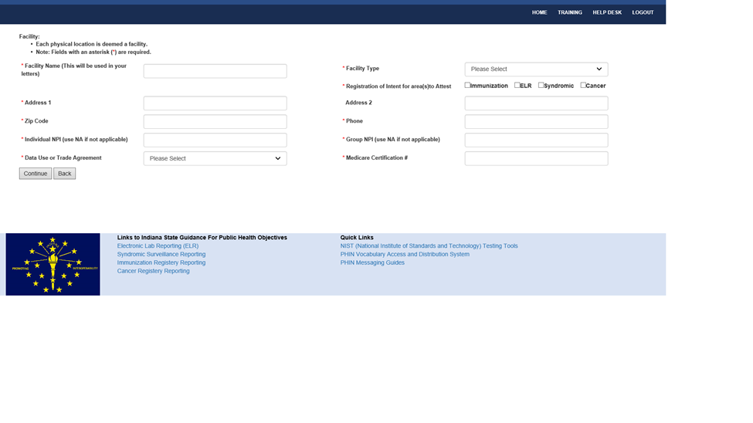

Once this process is completed the facility will be listed on the Promoting Interoperability Organization page, noted below:

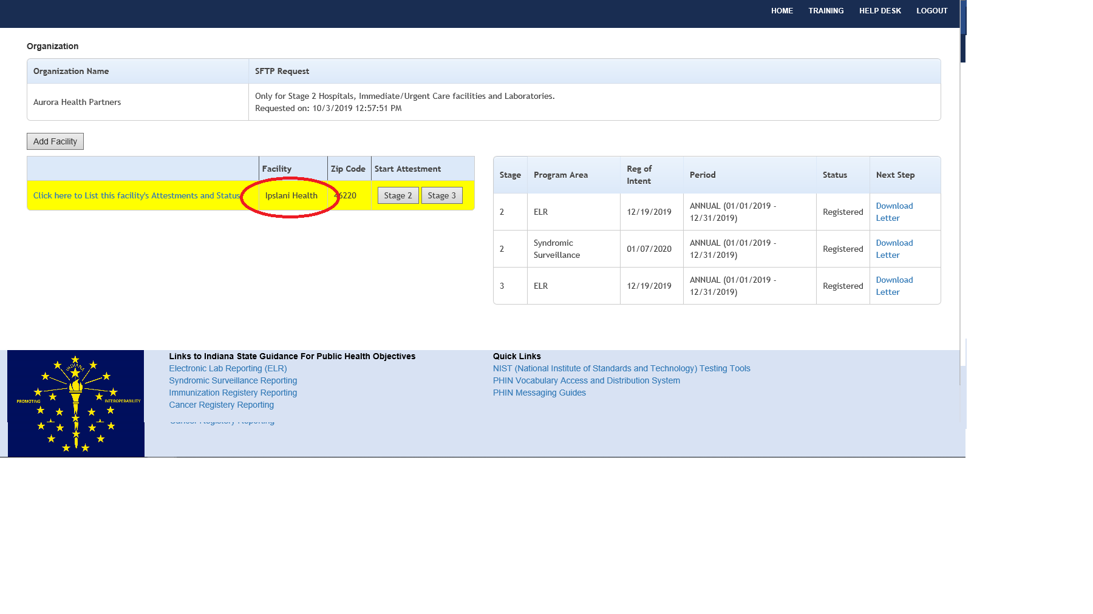

Stage 1 Registration (No Longer Accepting)

Before you start you will need you EHR vendor name, your ONC Certification number- the Medicare/Medicaid provider number (also known as OSCAR provider number, Medicare Identification number or Provider number), and a valid HL7 message.

Step 1—Click on the Stage 1 button on the Promoting Interoperability page to register for Stage 1.

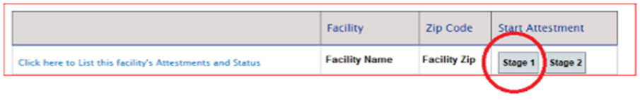

Step 2- fill out the Stage 1 Public Health Submission form-ALL fields must be completed or the form will not be submitted. When finished select “Continue”

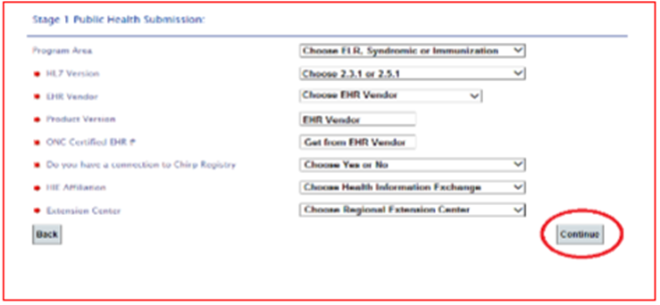

Step 3- On the Promoting Interoperability Organization page select “click here to list facility’s Attestments and Status”.

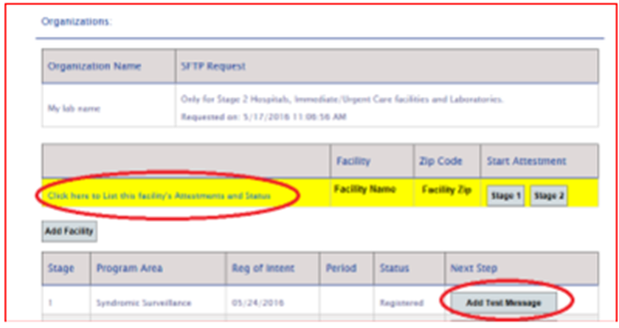

Stage 2 Registration

Before you start you will need you EHR vendor name, your ONC Certification number- the Medicare/Medicaid provider number (also known as OSCAR provider number, Medicare Identification number or Provider number), and a valid HL7 message.

THE REGISTRATION for Stage 2 is quite like Stage 1. Both the original registrant and the technical contact will receive a testing request email.

Step 1— On the Promoting Interoperability Home page click on the State 2 button.

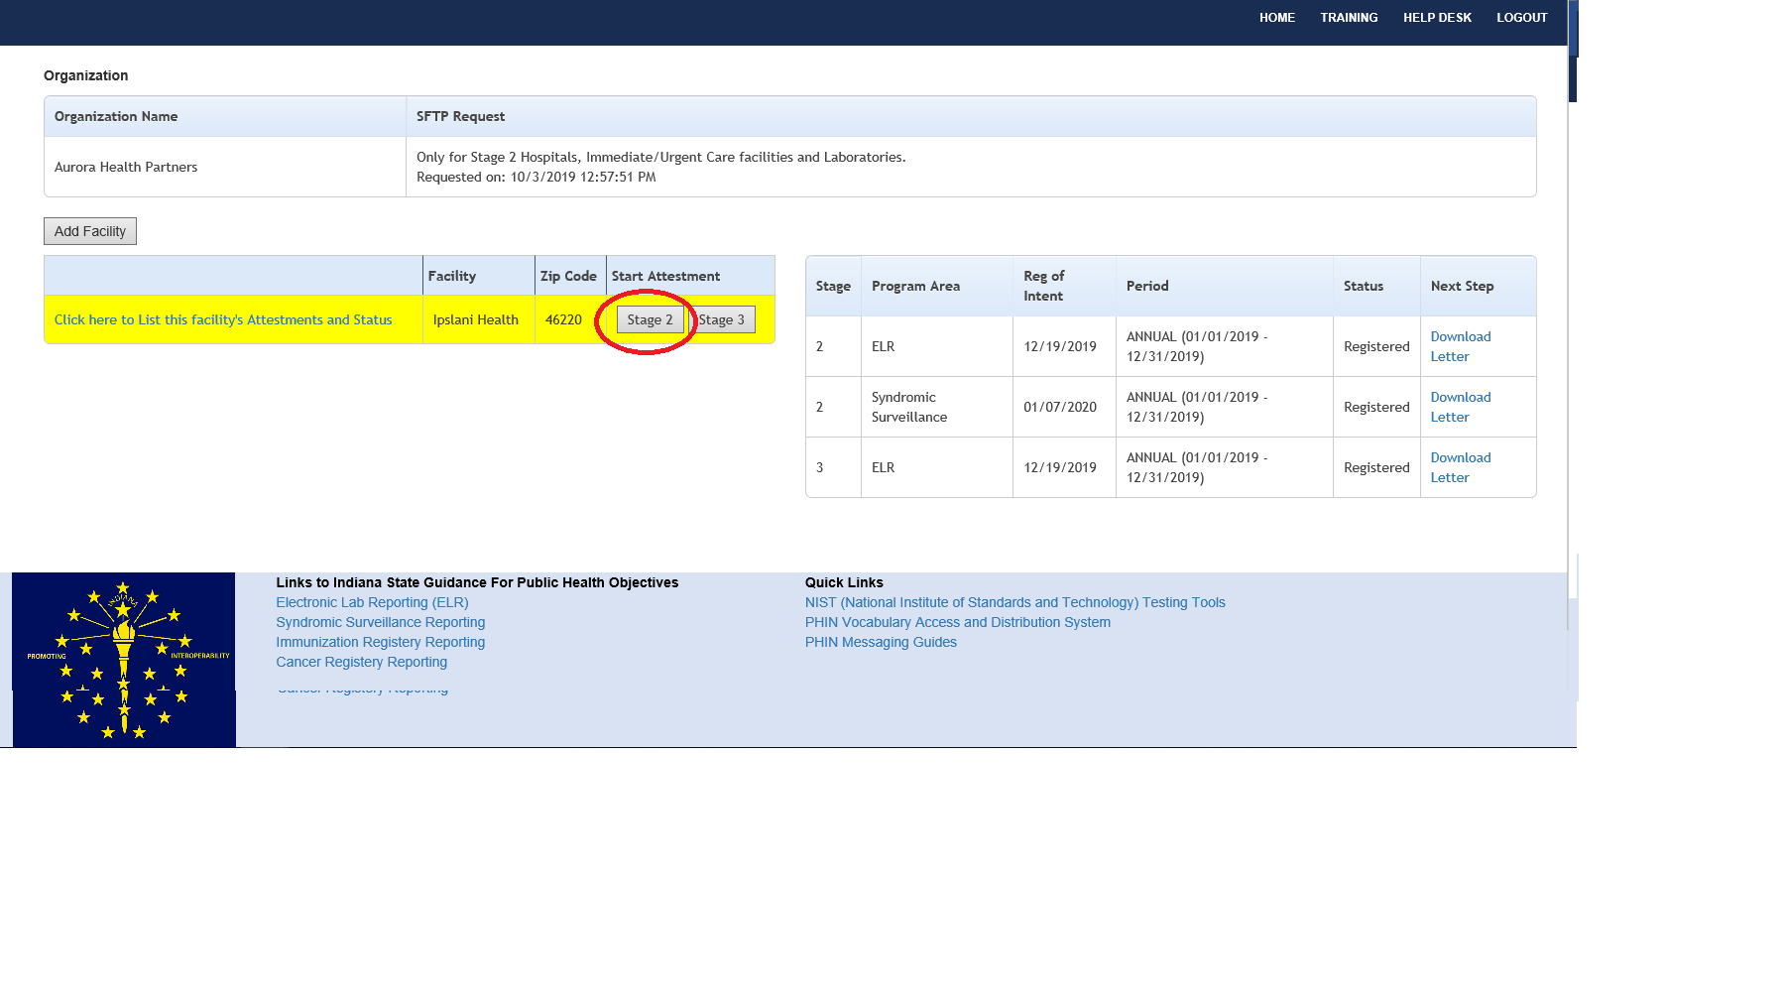

Step 2 — Fill out the Stage 2 Public Health Submission form (all fields to be completed).

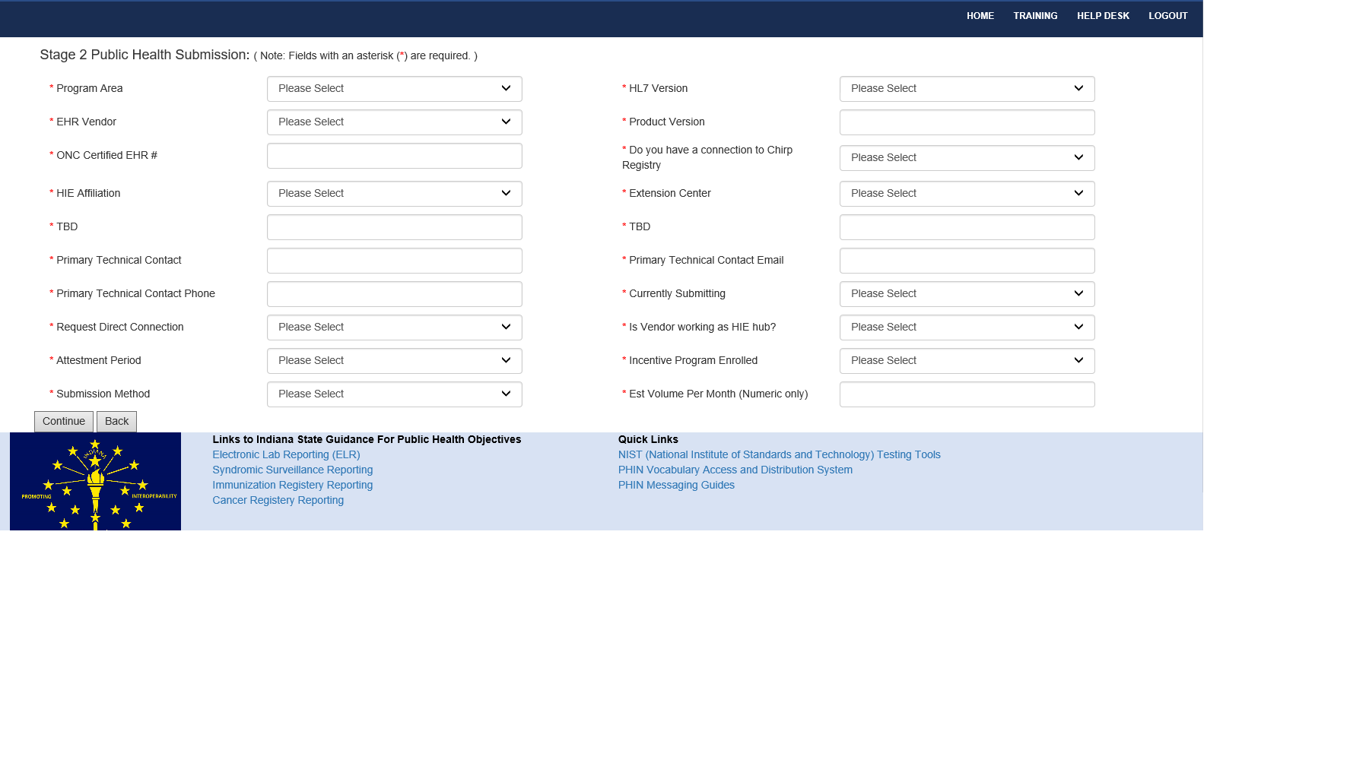

Please note — the form does change depending on the program area chosen. We ask that you email the Immunization team at repps@isdh.in.gov for the RXA.11.1 to confirm if it is vendor or CHIRP supplied.

Step 3 within Stage 2 and 3 form this field changes when entering **Program and appears after *” Extension Center”** Shown in the RED oval in the above diagram.

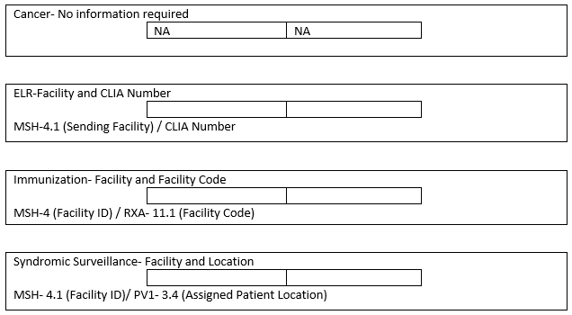

Download Stage 2 Letter

Once the Stage 2 Status has changed to “Registered” the “Download Letter” text will be a hypertext link and clickable.

Step 1 — Click on Download Letter to receive the Stage 2 Letter

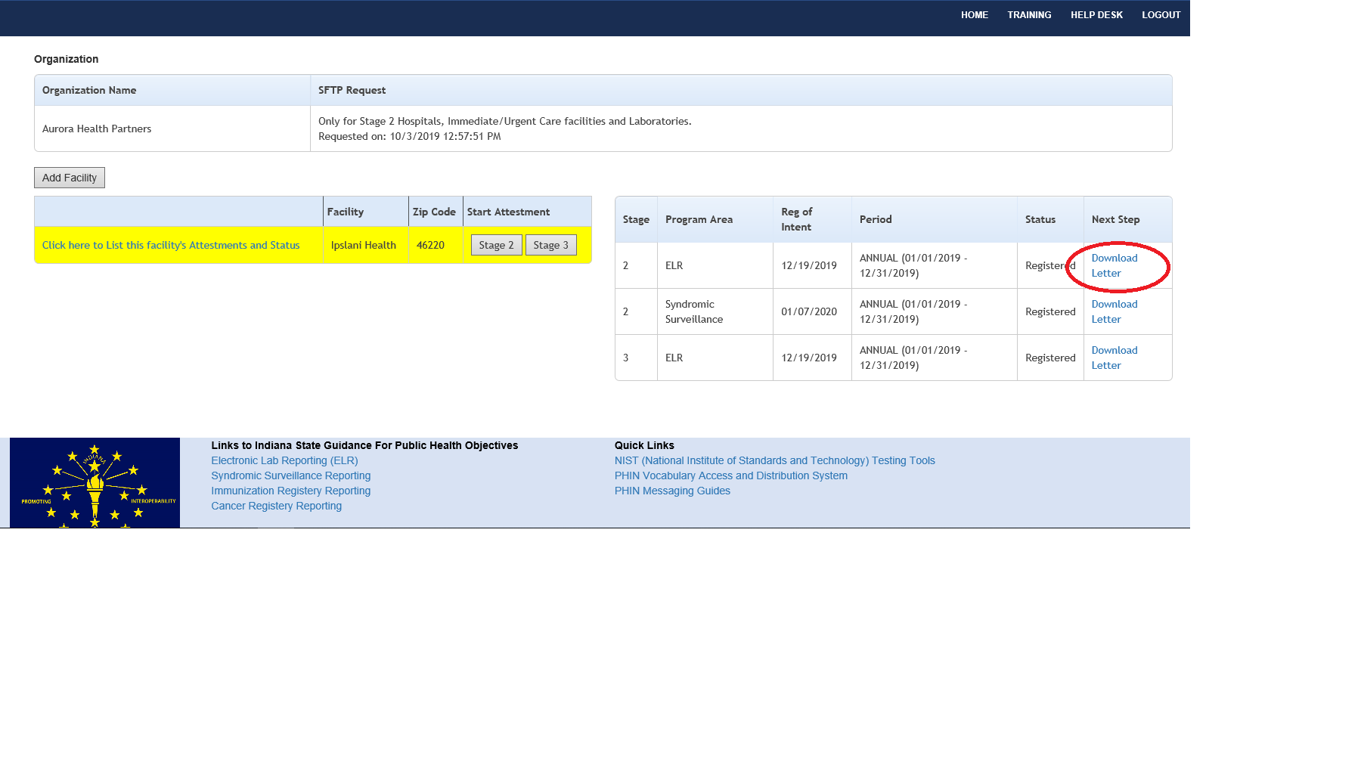

Step 2—Follow your computer prompt — depending on your web browser being used, clicking on the Download Letter button will force a prompt to save or open the document or the letter will be saved to your computer’s Downloads folder.

The two instances of To Be Determined (TBD) in the letter will be updated to reflect accurate dates when you start testing (first TBD) and when the/your feed goes live and into production (second TBD).

This letter can be downloaded more than once.

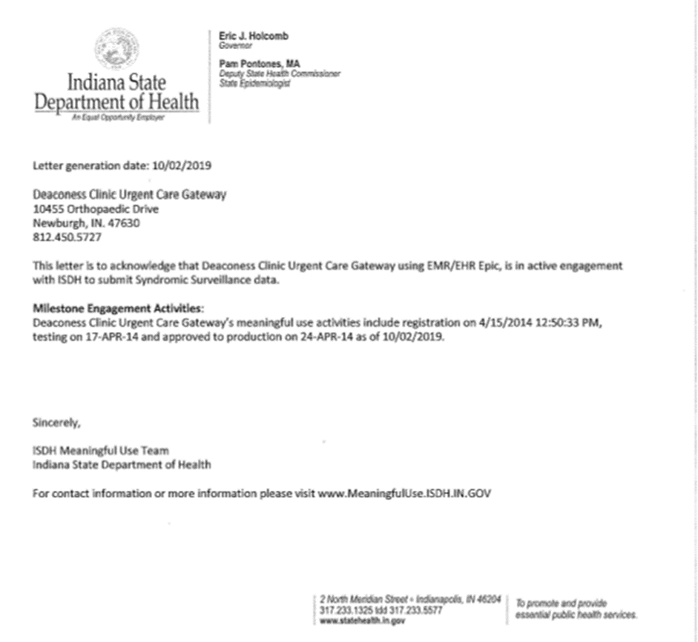

Please note: There are no “edit” or “delete” capabilities in the Meaningful Use website. Request changes by sending an email to [isdhelrss@isdh.in.gov](mailto:isdhelrss@isdh.in.gov)

**Stage 3 Registration**

Before you start you will need your EHR vendor name, your technical contact’s information, your ONC Certification number -ONC Certification number — the Medicare/Medicaid Provider Number (also known as the OSCAR Provider Number, Medicare Identification Number or Provider Number) , and a valid HL7 message

The registration for Stage 3 is identical to Stage 2. Both the original registrant and the technical contact will receive a testing request email.

Review the steps under Stage 2 to complete Stage 3

**Download Stage 3 Letter**

The process for downloading Stage 3 letters has not changed. Please review the process for Download Stage 2 Letter and follow the same steps as noted, just select all that applies to Stage 3 Letters.